Week 5

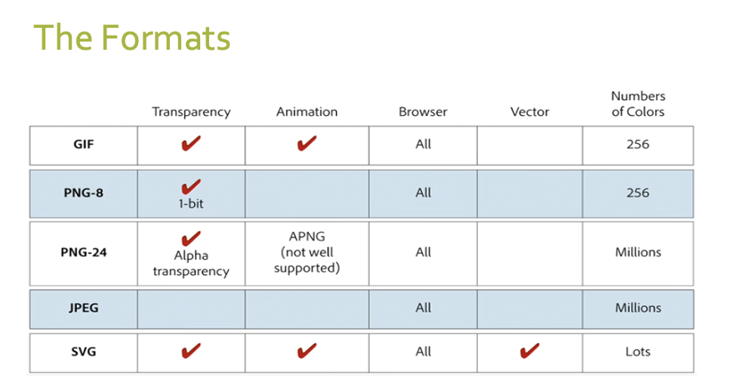

Gifs- animations

PNG-8-logos

JPEG-pictures

**Pixels**

* Pictures are made up of dots of color
* A pixel is one dot in an image
* There are 72 pixels per inch on a screen
* The number of pixels per inch is abbreviated PPl

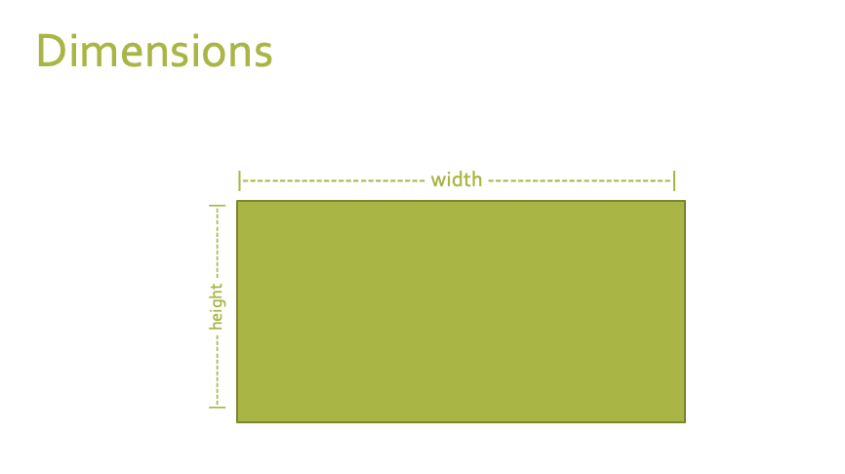

Week 6

**Wireframe**

* Allows us to design basic layout of a website without thinking about design
* They help us focus on user experience
* Takes focus away from design, colors, fonts and just talks about location of content on the page
* Helps us focus on user experience
* Shows the weight of different areas of the website

**What is CSS**

* Standard for defining presentation of HTML documents

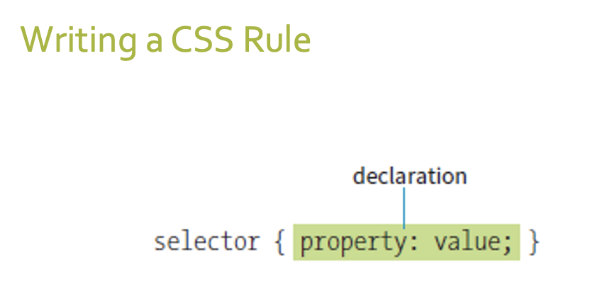

**Ways to add CSS**

* Linked or external
  + Style sheet is a separate file with .css extension. You can use this to style all site pages

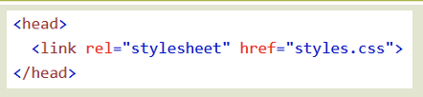

* Embedded or internal
  + Styles are at the top of your .html file inside of the head tag

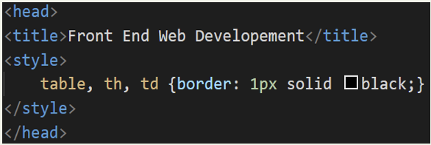

* Inline
  + Styles are in attributes on your elements inside the body tag. This is frowned upon

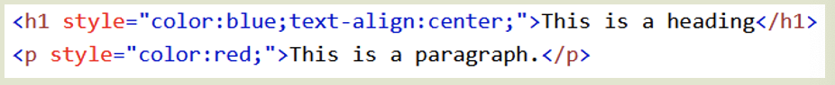

**Absolute**

* Have predefined meaning or real-world equivalents. They are not appropriate for web pages

**Relative**

* Relative units are based on the size of something else, such as the default text size

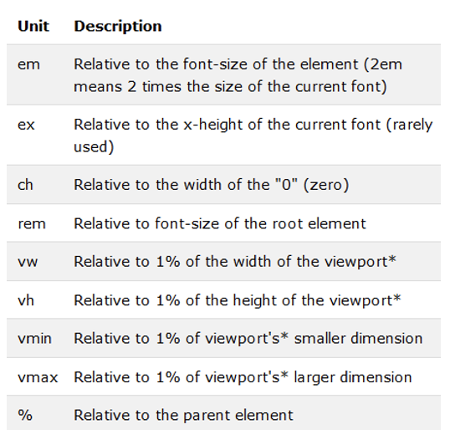

|  |  |
| --- | --- |
| **Property** | **Description** |
| color | Specifies the foreground color (text and borders) for an element |
| direction | Indicates whether the text reads left-to-right or right- to-left |
| font | A shorthand property that combines font properties |
| font-family | Specifies a typeface or generic font family |
| font-feature-settings | Allows access to lesser-used OpenType features |
| font-kerning | Controls how browsers implement kerning data (space between characters) |
| font-language-override | Controls use of language-specific glyphs |
| font-size | Specifies the size of the font |
| font-size-adjust | Matches the x-height of a fallback font with the speci- fied font |
| font-stretch | Selects a condensed, normal, or extended font |
| font-style | Specifies italic or oblique fonts |
| font-synthesis | Controls whether a browser may simulate bold or italic fonts |
| font-variant | Specifies a small-caps font |
| font-variant-alternates | Selects alternate versions of character glyphs |
| font-variant-caps | Selects small caps and similar alternates when available |
| font-variant-east-asian | Selects alternate glyphs in Chinese, Japanese, and Korean |
| font-variant-ligatures | Selects ligatures for certain letter pairs when available |
| font-variant-numeric | Selects alternate number glyphs |
| font-variant-position | Selects subscript or superscript character glyphs |
| font-weight | Specifies the boldness of the font |
| hanging-punctuation | Indicates whether the punctuation may hang outside the content box |
| hyphens | Controls how text is hyphenated |
| letter-spacing | Inserts space between letters |
| line-break | Describes rules for breaking lines |
| line-height | Indicates the distance between baselines of neighbor- ing text lines |
| Property | Description |
| list-style-image | Specifies an image to be used as a list marker |
| list-style-position | Puts a list marker inside or outside the content area |
| list-style-type | Selects the marker type for list items |
| overflow-wrap | Specifies whether the browser can break lines within words to prevent overflow |
| tab-size | Specifies the length of a tab character |
| text-align | Indicates the horizontal alignment of text |
| text-align-last | Specifies how the last line in justified text is aligned |
| text-decoration | Specifies underlines, overlines, and lines through |
| text-indent | Specifies the amount of indentation of the first line in a block |
| text-justify | Denotes how space is distributed in justified text |
| text-shadow | Adds a drop shadow under the text |
| text-transform | Changes the capitalization of text when it displays |
| unicode-bidi | Works with Unicode bidirectional algorithms |
| vertical-align | Adjusts the vertical position of inline elements relative to the baseline |
| white-space | Specifies how whitespace in the source is displayed |
| word-break | Specifies whether to break lines within words |
| word-spacing | Inserts space between words |
| word-wrap | Indicates whether the browser can break lines within words to prevent overflow (same as overflow-wrap) |

**Group selectors**

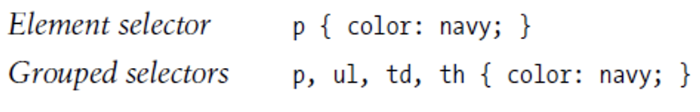

**Descendant selector**



**Id selectors**

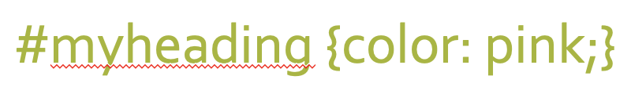

**Class selectors**

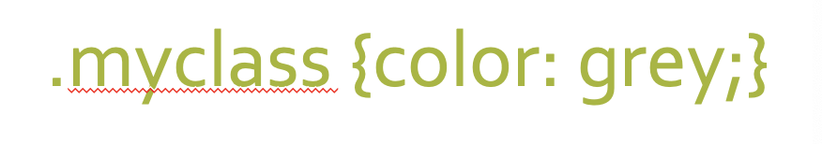

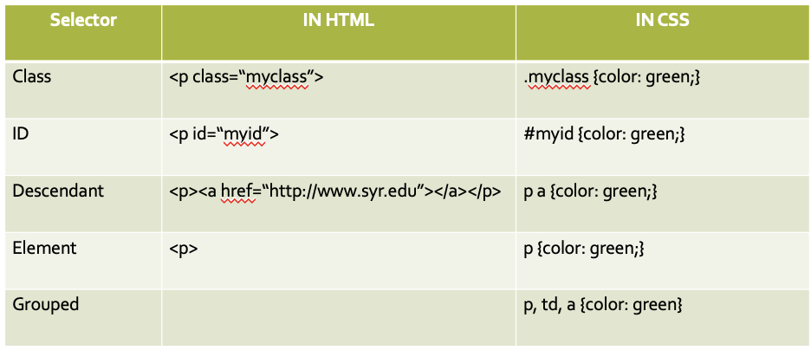

Week 7

**Hex color**

* Hexadecimal RGB values must be preceded by the # symbol

**New selector – pseudo selectors**

* Applies style to a state of an element
  + What does an element look like when your mouse is over it
  + What does an element look like after it’s been clicked
  + What does a form filed look like when it is the one you are using
  + :hover- applies when the mouse pointer is over the element

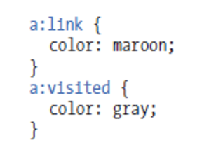

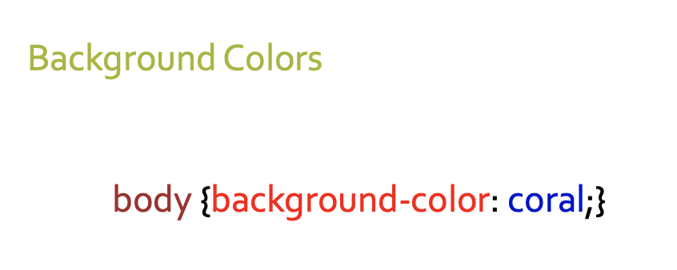

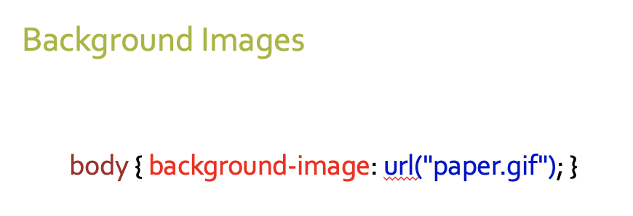

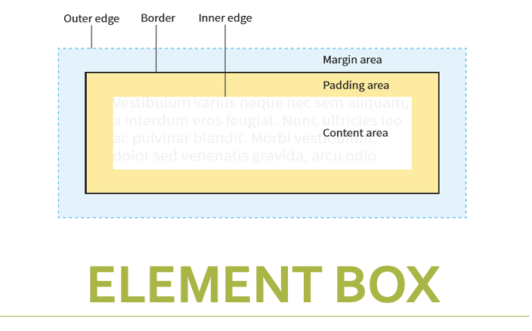

Week 8

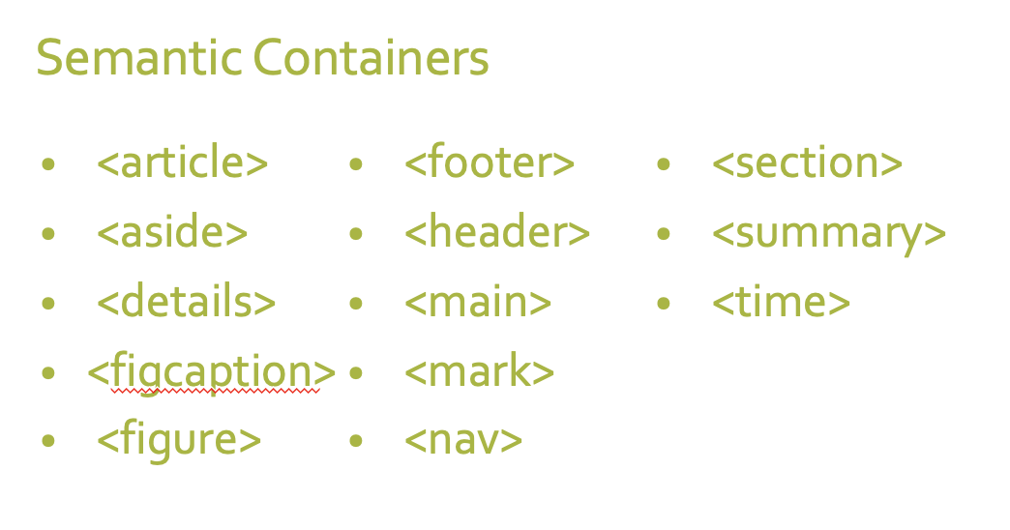

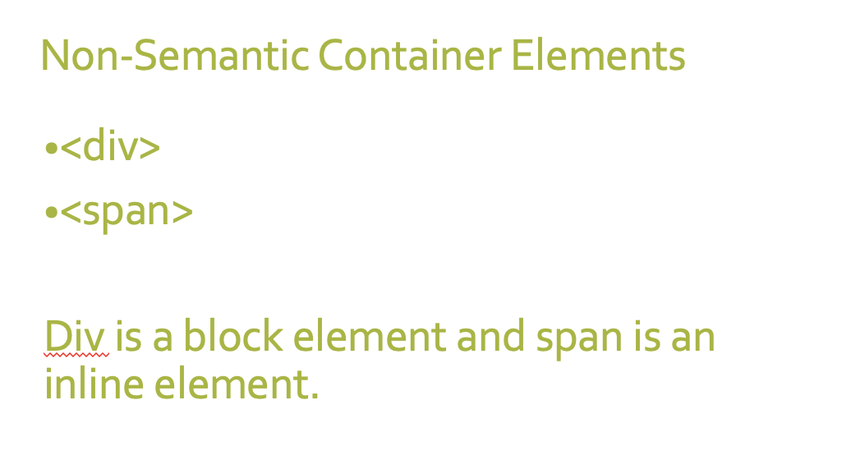

**What is a float?**

* An element pushed to the left or right allowing everything after the element to wrap around it

**Clearing floats**

* To stop the rest of the page from flowing around an element use the clear CSS property

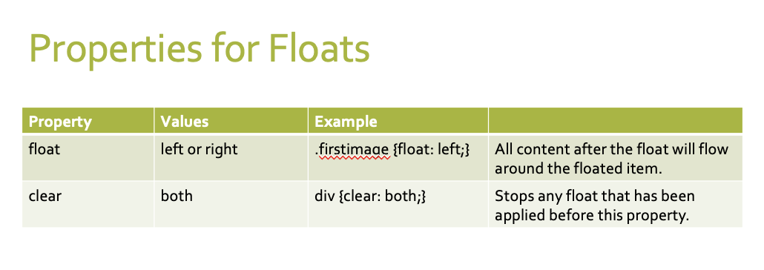

**What is flexbox?**

* A way of laying out elements on a web page
* Elements/containers are laid out in rows and columns

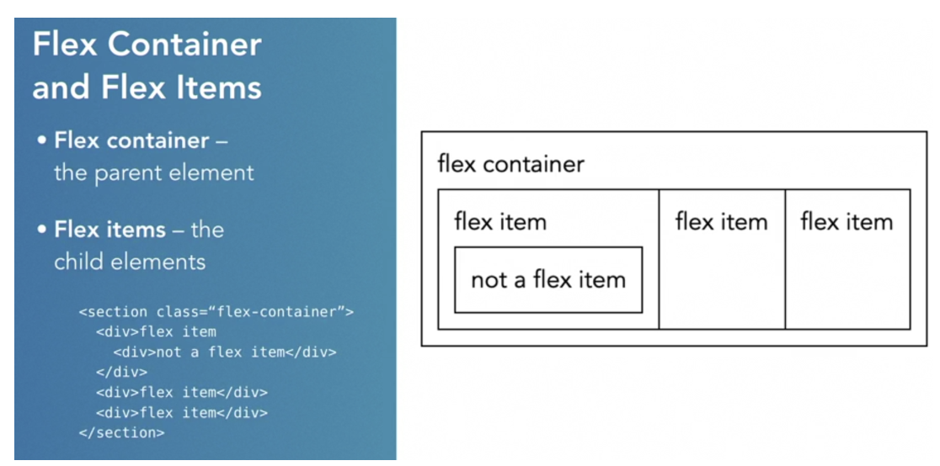

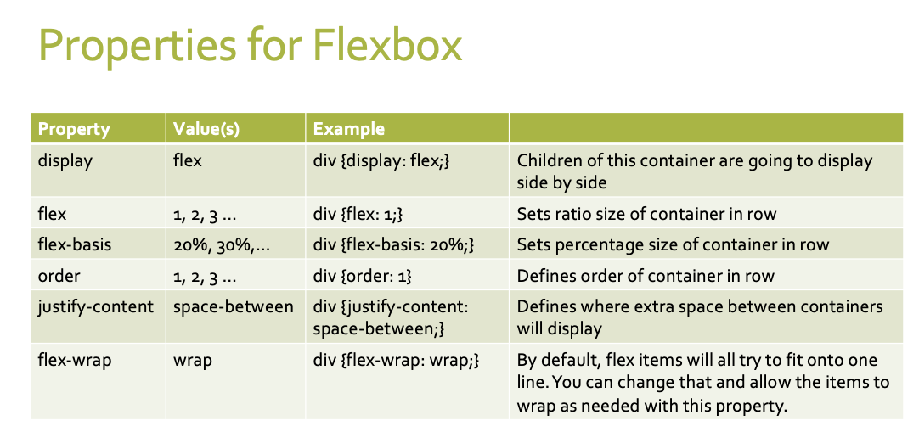

**Week 9**

**Centering inline elements**

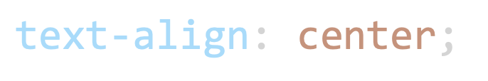

**Centering Block elements**

* block elements take up 100% of the page width by default so you must first set a widthor it won’t look like anything happened

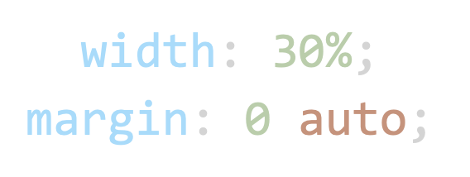

**Centering with flexboxes**

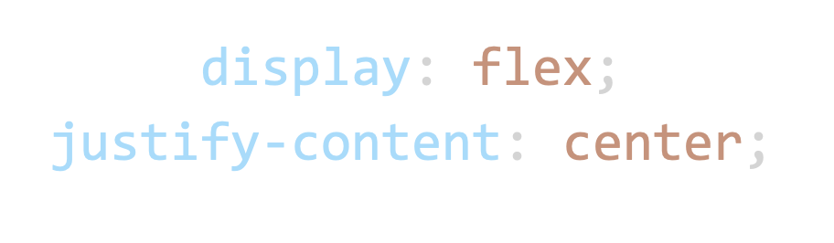

**Flex-end**

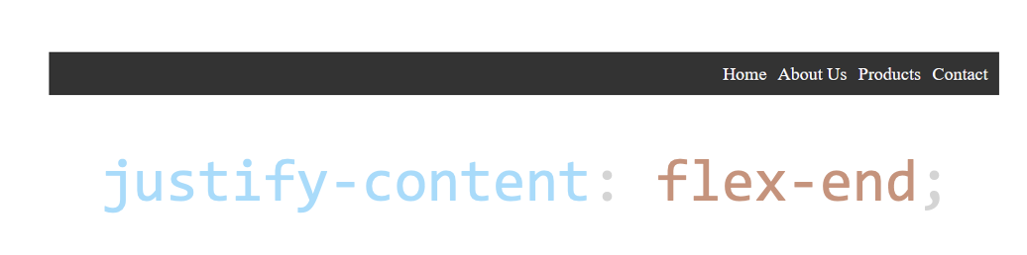

**Space-around**

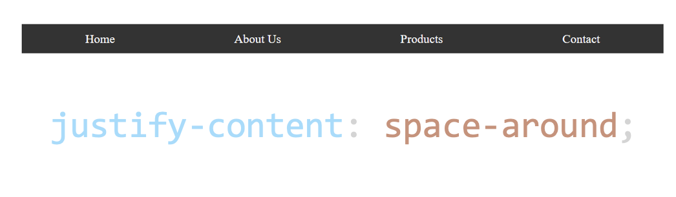

**Space-between**

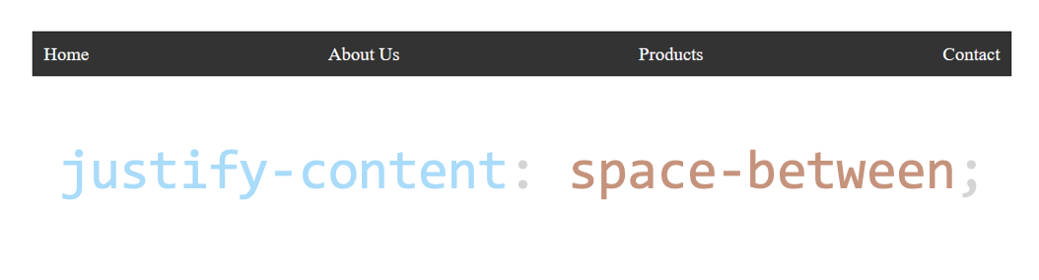

**Elements on the left and right**

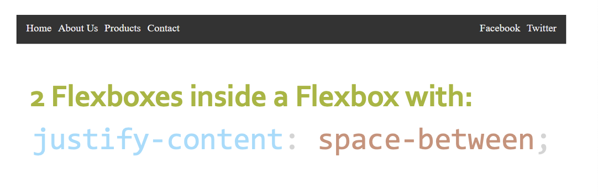

**Week 10**

**What is RWD?**

* Making your sit look good on:
  + Desktops
  + Tablets
  + Mobile devices

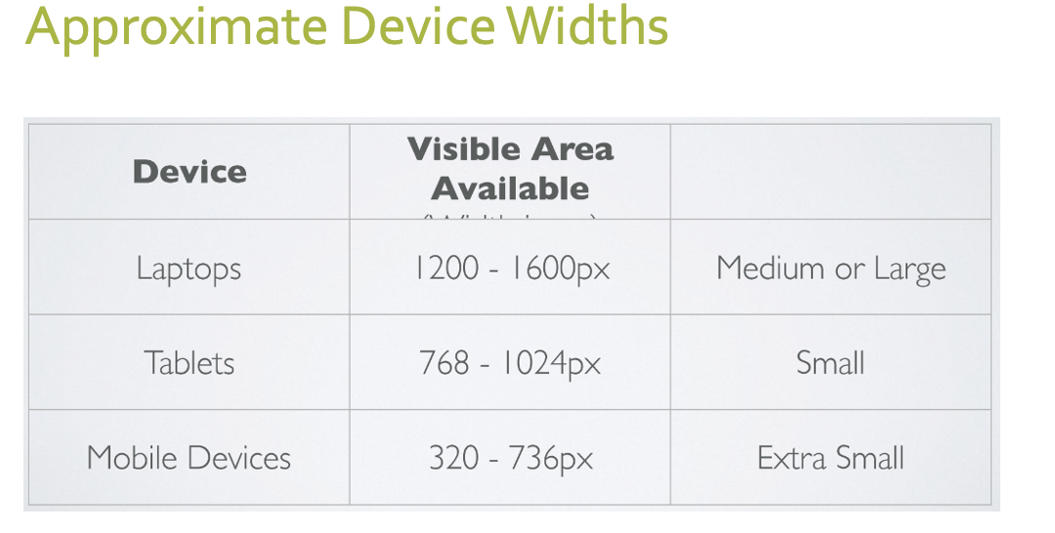

**What will we do to size our sites?**

* Flexible images
* Flexible grids
* Media queries- allow us to give CSS rules strictly by width of screen

**Viewport**

* The browsers viewport is the area of the window in which web content can be seen. This is often not the same size as the rendered page, in which case the browser provides scrollbars
* If you don’t control the viewport, your site will shrink to fit the device size. That’s when you see a teeny tiny webpage shrunken down to git your phone screen

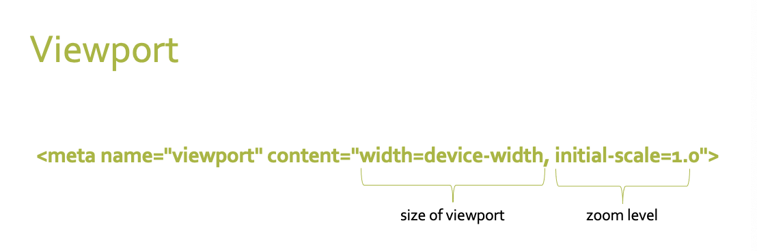

**Making images flexible**

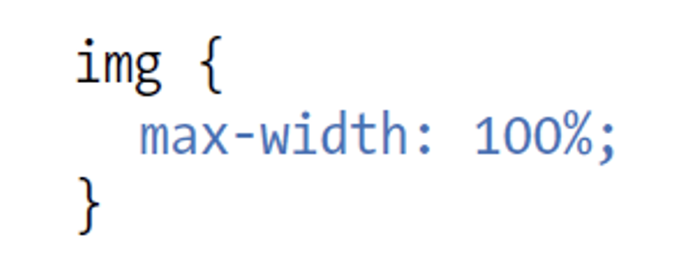

**Flexbox wrapping**

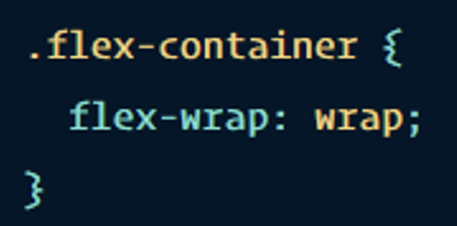

**What is a media query?**

* Different styles based on
  + Width of bowser
  + Orientation of browser
  + Screen resolution
  + Whether you are printing or view on screen

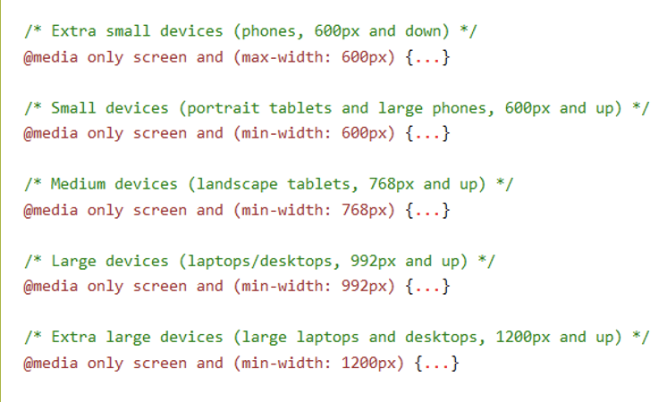

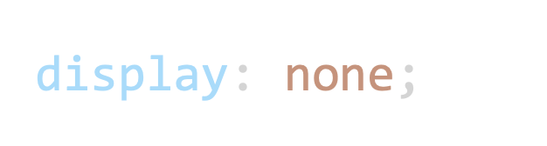

* Used with the media queries you can remove an item from the screen, for example at cell phone size